# Skewed reps uniform tone

## Skewed reps uniform tones low vol

#low_vol_tones are 500, 550, 600, 650, 700, 750, 800)

#high_vol_tones are [ 350, 450, 550, 650, 750, 850, 950]

* file_name = "min 1, max 7, skewed reps uniform tones.txt"
  + key: 500, counts: 707
  + key: 550, counts: 846
  + key: 600, counts: 730
  + key: 650, counts: 794
  + key: 700, counts: 707
  + key: 750, counts: 671
  + key: 800, counts: 720
  + **Repeats distribution {1: 51, 6: 250, 5: 250, 7: 249, 3: 75, 4: 75, 2: 50}**
  + Max_repeats = 7
  + **Avg # repeats 5.169**
  + **StDev # repeats 1.69153785068508**
  + **Mean tone frequency 646.7729468599034 Hz**
  + **StDev tone frequency 99.0935811183145 Hz**

## Skewed reps uniform tones high vol - linear

* file_name = "min 1, max 7, skewed reps uniform tones high vol.txt"
  + key: 350, counts: 707
  + key: 450, counts: 846
  + key: 550, counts: 730
  + key: 650, counts: 794
  + key: 750, counts: 707
  + key: 850, counts: 671
  + key: 950, counts: 720
  + **Repeats distribution {1: 51, 6: 250, 5: 250, 7: 249, 3: 75, 4: 75, 2: 50}**
  + Max repeats 7
  + **Avg # repeats 5.169**
  + **StDev # repeats 1.69153785068508**
  + **Mean tone frequency 643.5458937198067 Hz**
  + **StDev tone frequency 198.187162236629 Hz**

## Uniform reps uniform tones low vol

* file_name = "min 1, max 7, uniform reps uniform tones.txt"
  + key: 500, counts: 550
  + key: 550, counts: 623
  + key: 600, counts: 528
  + key: 650, counts: 613
  + key: 700, counts: 578
  + key: 750, counts: 490
  + key: 800, counts: 611
  + **Repeats distribution {1: 145, 5: 142, 6: 143, 3: 143, 7: 142, 4: 143, 2: 142}**
  + Max repeats 7
  + **Avg # repeats 3.992**
  + **StDev # repeats 2.002984759789237**
  + **Mean tone frequency 649.5867768595041 Hz**
  + **StDev tone frequency 100.1086539465779 Hz**

## Uniform reps uniform tones high vol - linear

* file_name = "min 1, max 7, uniform reps uniform tones high vol.txt"
  + key: 350, counts: 550
  + key: 450, counts: 623
  + key: 550, counts: 528
  + key: 650, counts: 613
  + key: 750, counts: 578
  + key: 850, counts: 490
  + key: 950, counts: 611
  + **Repeats distribution {1: 145, 5: 142, 6: 143, 3: 143, 7: 142, 4: 143, 2: 142}**
  + Max_repeats = 7
  + **Avg # repeats 3.992**
  + **StDev # repeats 2.002984759789237**
  + **Mean tone frequency 649.1735537190083 Hz**
  + **StDev tone frequency 200.2173078931558 Hz**

## High vol is non-linear

This is so we can compare the same error in Hz with a higher stimulus Hz volatility

#low_vol_tones are 500, 550, 600, 650, 700, 750, 800)

#high_vol_tones are [ 300, 500, 600, 650, 700, 800, 1000]

### Skewed reps uniform tones high vol - nonlinear

* **file_name2 = "min 1, max 7, skewed reps** **uniform** **tones high vol.txt"**
  + key: 300, counts: 707
  + key: 500, counts: 846
  + key: 600, counts: 730
  + key: 650, counts: 794
  + key: 700, counts: 707
  + key: 800, counts: 671
  + key: 1000, counts: 720
  + Max repeats 7
  + Repeats distribution {1: 51, 6: 250, 5: 250, 7: 249, 3: 75, 4: 75, 2: 50}
  + **Avg # repeats 5.169**
  + **StDev # repeats 1.69153785068508**
  + **Mean tone frequency 645.5845410628019 Hz**
  + **StDev tone frequency 202.6069738384643 Hz**

### Uniform reps uniform tones high vol - nonlinear

* file_name4 = "min 1, max 7, uniform reps uniform tones high vol.txt"
* Max repeats 7
* Repeats distribution {1: 145, 5: 142, 6: 143, 3: 143, 7: 142, 4: 143, 2: 142}
* key: 300, counts: 550
* key: 500, counts: 623
* key: 600, counts: 528
* key: 650, counts: 613
* key: 700, counts: 578
* key: 800, counts: 490
* key: 1000, counts: 611
* Avg # repeats 3.992
* StDev # repeats 2.002984759789237
* Mean tone frequency 650.9767092411721 Hz
* StDev tone frequency 206.35179808155408 Hz

## Graphs

### Low vs high vol - linear graph

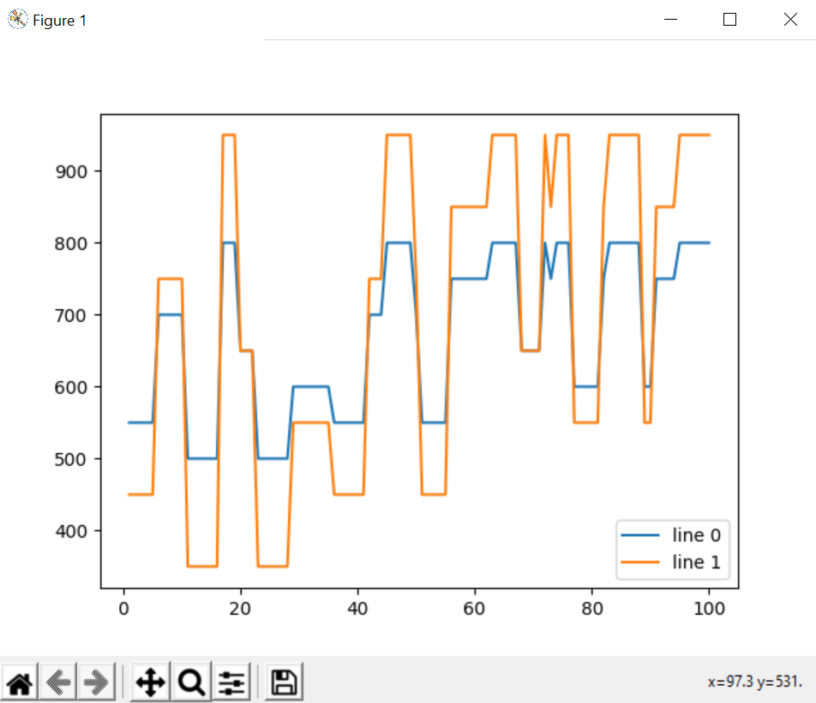 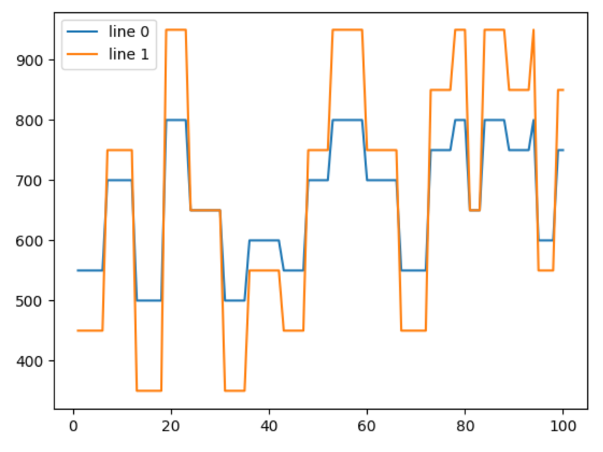

### Low vs high vol – nonlinear graph

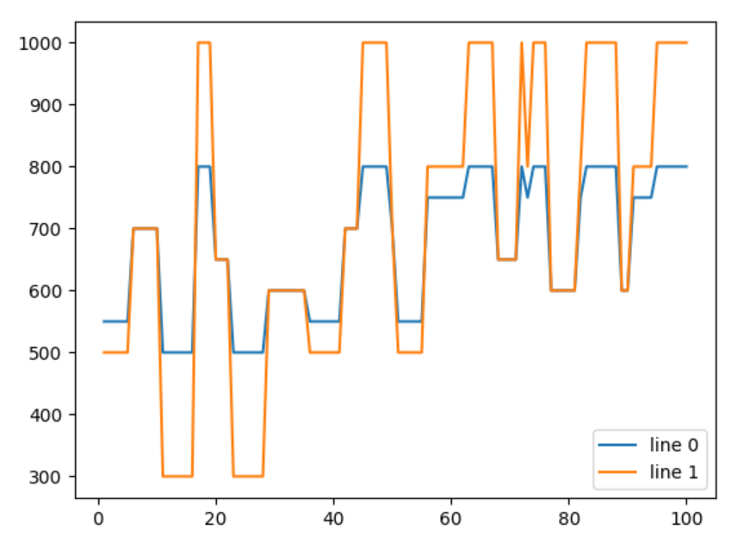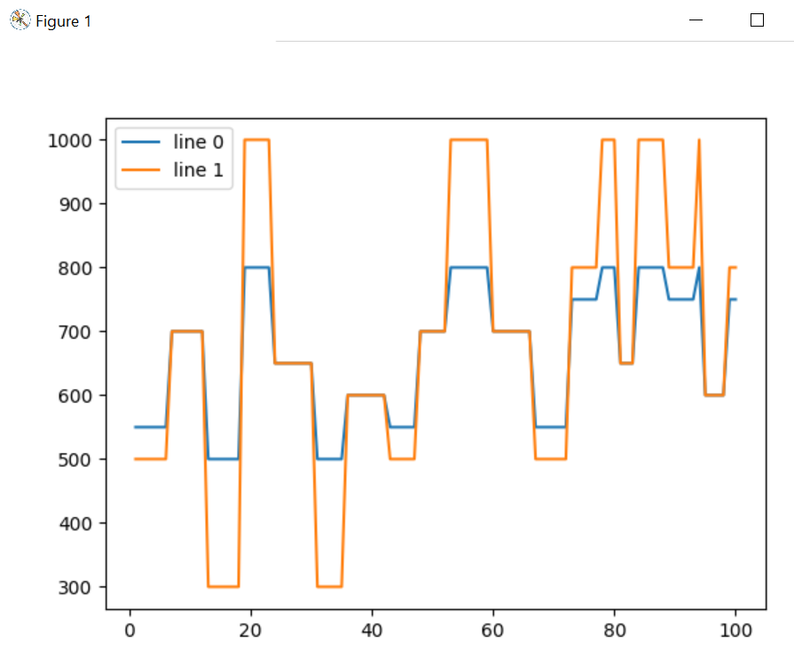

### Uniform vs skewed reps – low vol

The tones follow the same path, but the orange sequence uses the skewed distribution which contains a little more repeats on average (and more uncertainty as to the number of repetitions)

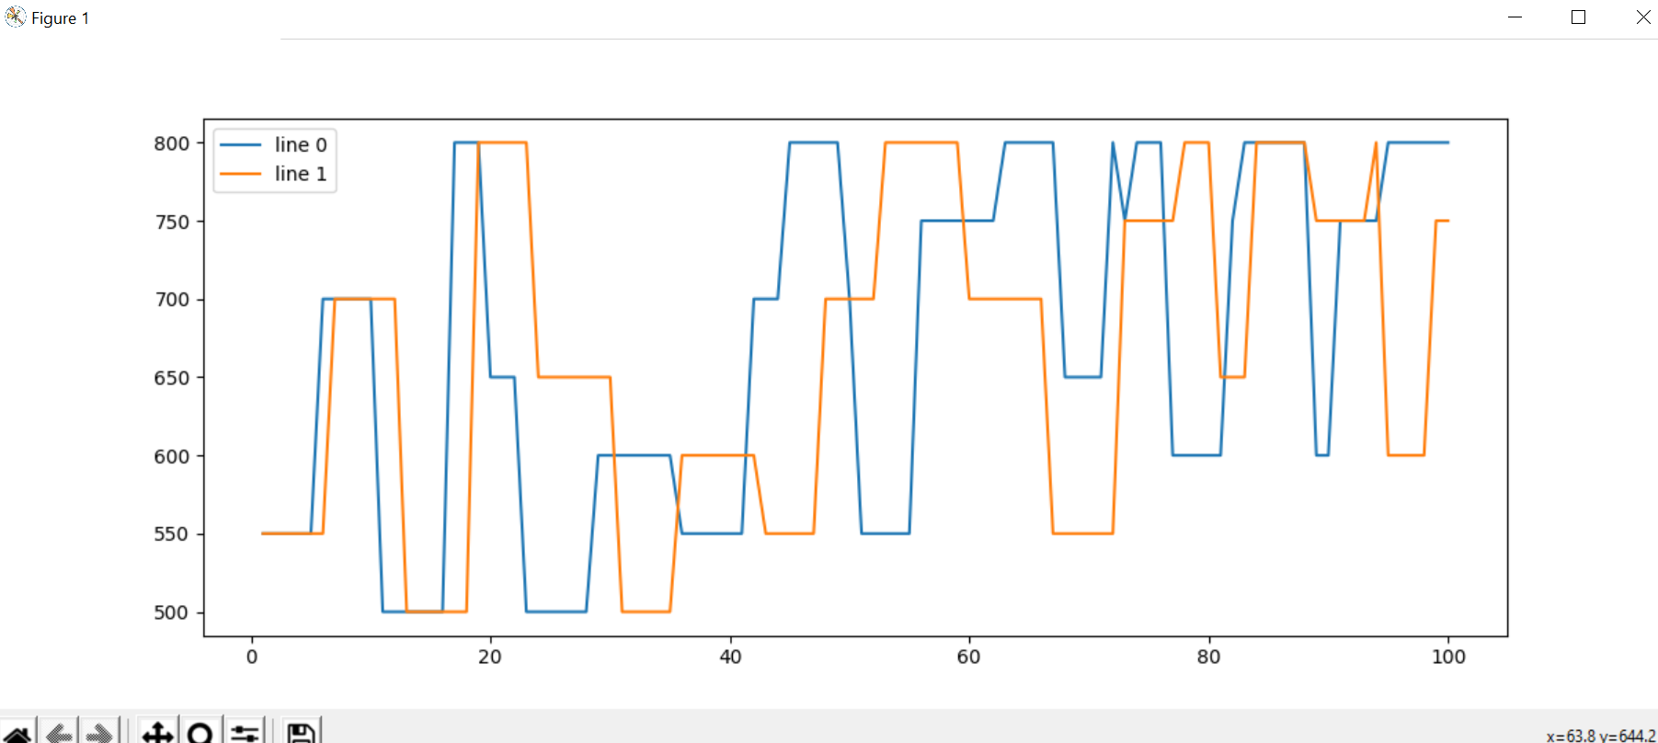

# Skewed reps Skewed Tones

## Skewed reps Skewed Tones low vol

file_name = " min 1, max 7, skewed reps skewed tones.txt"

* Mean tone frequency 697.256038647343 Hz
* StDev tone frequency 90.62961279152924 Hz
* Max repeats 7
* Repeats distribution {1: 51, 6: 250, 5: 250, 7: 249, 3: 75, 4: 75, 2: 50}
* key: 500, counts: 354
* key: 550, counts: 338
* key: 600, counts: 450
* key: 650, counts: 518
* key: 700, counts: 1166
* key: 750, counts: 1134
* key: 800, counts: 1215
* Avg # repeats 5.169
* StDev # repeats 1.69153785068508
* Counts
* Total count 5175

## Skewed reps Skewed Tones high vol

file_name = " min 1, max 7, skewed reps skewed tones high vol.txt"

* Mean tone frequency 738.2222222222222 Hz
* StDev tone frequency 191.14940634179655 Hz
* Max repeats 7
* Repeats distribution {1: 51, 6: 250, 5: 250, 7: 249, 3: 75, 4: 75, 2: 50}
* key: 1000, counts: 1215
* key: 300, counts: 354
* key: 500, counts: 338
* key: 600, counts: 450
* key: 650, counts: 518
* key: 700, counts: 1166
* key: 800, counts: 1134
* Avg # repeats 5.169
* StDev # repeats 1.69153785068508
* Counts
* Total count 5175

# Uniform reps Skewed Tones

## Uniform reps Skewed Tones low vol

file_name = " min 1, max 7, skewed reps skewed tones.txt"

* Mean tone frequency 697.1950914099674 Hz
* StDev tone frequency 90.31290046794012 Hz
* Max repeats 7
* Repeats distribution {1: 145, 5: 142, 6: 143, 3: 143, 7: 142, 4: 143, 2: 142}
* key: 500, counts: 290
* key: 550, counts: 248
* key: 600, counts: 307
* key: 650, counts: 409
* key: 700, counts: 950
* key: 750, counts: 875
* key: 800, counts: 914
* Avg # repeats 3.992
* StDev # repeats 2.002984759789237
* Counts
* Total count 3993

## Uniform reps Skewed Tones high vol

file_name = " min 1, max 7, skewed reps skewed tones high vol.txt"

* Mean tone frequency 736.3010267968946 Hz
* StDev tone frequency 191.32230380520593 Hz
* Max repeats 7
* Repeats distribution {1: 145, 5: 142, 6: 143, 3: 143, 7: 142, 4: 143, 2: 142}
* key: 1000, counts: 914
* key: 300, counts: 290
* key: 500, counts: 248
* key: 600, counts: 307
* key: 650, counts: 409
* key: 700, counts: 950
* key: 800, counts: 875
* Avg # repeats 3.992
* StDev # repeats 2.002984759789237
* Counts
* Total count 3993

## Graphs

### Skewed reps skewed tones low vs high vol

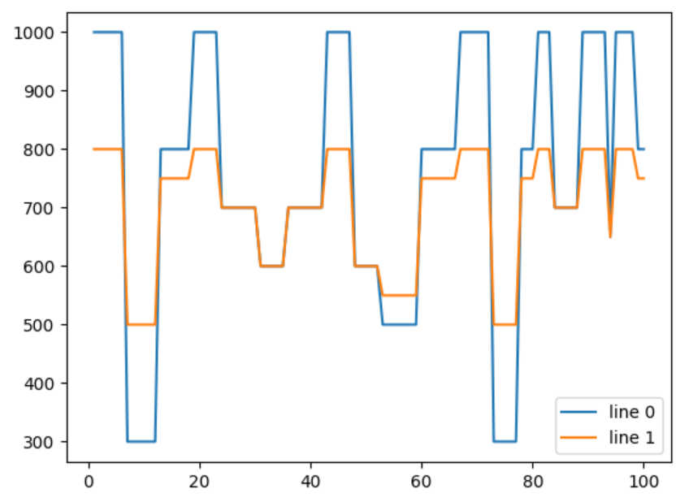

### Uniform reps skewed tones low vs high vol

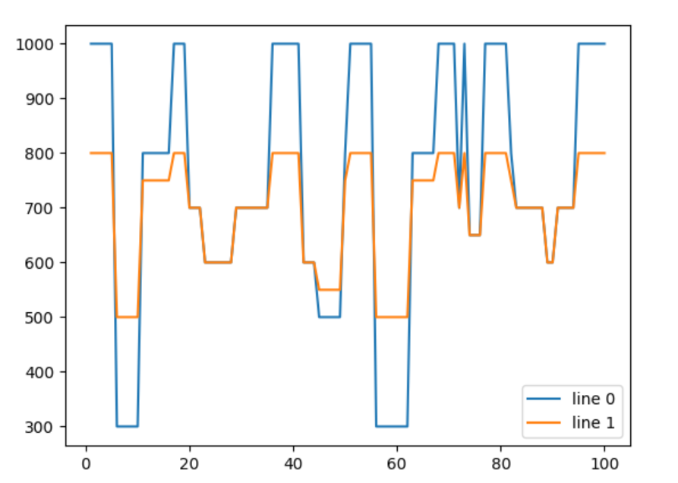

### Uniform reps skewed tones vs skewed reps skewed tones low vol

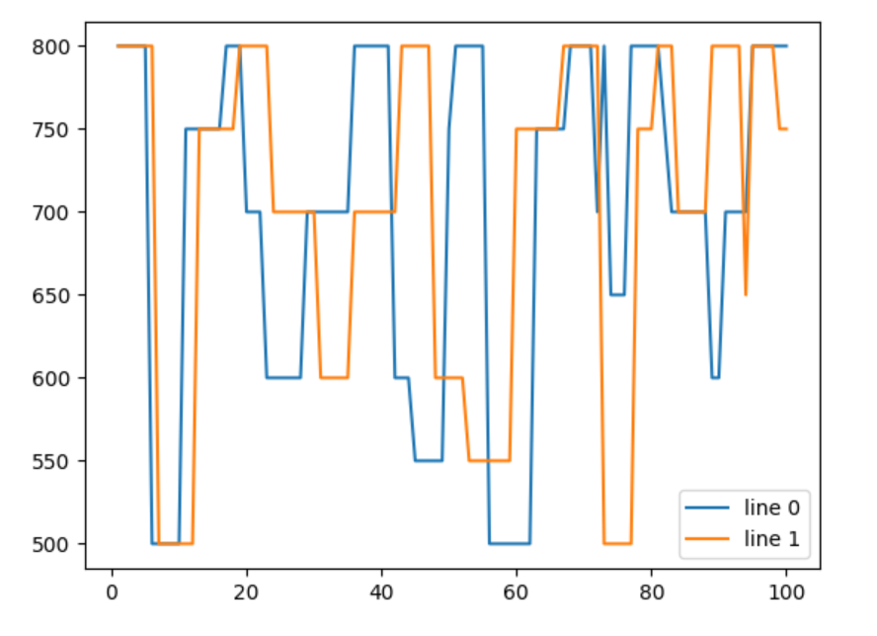

### Uniform reps skewed tones vs skewed reps skewed tones high vol

